Advance JAVA
Topic Sequence
1) JDBC
2) Spring (spring core, Spring JDBC, spring MVC, spring AOP)
3) Spring boot and restapi

JDBC: JDBC stands for Java Database Connectivity and it is used for connect your java application with database application means using JDBC we can work with database means insert record in database, delete record from database , update record in database , select record from database etc
JDBC is API or some inbuilt classes and interfaces which help us to work with database.

Steps to work with JDBC?
1) Add java.sql package in application
Here java.sql is package which contains some classes and interfaces which is responsible for
Connect java application with database.
import java.sql.*;
2) Load driver
Q. what is driver?
Driver are the some inbuilt classes which is contain some rules and some logics which help us to work
with database as well as connect database
There are four types of Driver classes
1) Type1
2) Type2
3) Type3
4) Type4
Note: we will discuss all types of driver in detail at end of topic so now we want to discuss about
Type1 driver

Type1 driver is ODBC driver (ODBC) stands for open database connectivity. This type of driver is used for connect your java application with any type of database and ODBC concept is introduced by Microsoft.
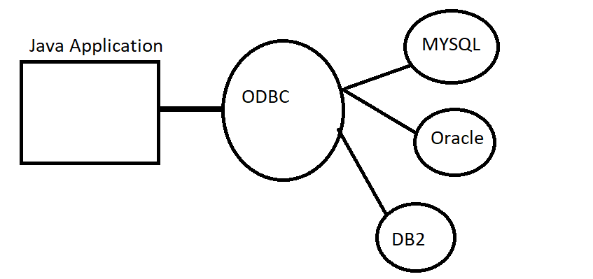
If we think about above diagram we have java application and we connect this application with database using ODBC the benefit is we can connect your java application with any database using ODBC.
if we want to work with type1 driver we have inbuilt class name as sun.jdbc.odbc.JdbcOdbcDriver Here sun.jdbc.odbc is package and JdbcOdbcDriver is class name so if we want to use this driver first we have to import sun.jdbc.odbc package and create object of JdbcOdbcDriver class
import sun.jdbc.odbc.*;
JdbcOdbcDriver d = new JdbcOdbcDriver();

Note: type1 driver is removed from JDK 1.8 version of JAVA.

Why type1 driver removed from JDK 1.8 version of JAVA
I) type1 driver is platform dependent driver because they design C and C++ means type1 driver only support to windows operating system not other
ii) Type1 driver not support to network programming means if we use type 1 driver then your java application and your database must be present on same machine
So if we want to work with JDBC we have to type4 driver

What is type4 driver?
type4 driver is vendor specific driver class (here vendor means database company) like as oracle , MYSQL etc here vendor specific means if we use MYSQL in backend then MYSQL provide class to us for database connectivity purpose in the form of .jar file , if we use Oracle in backend then Oracle provide class to us for database connectivity purpose in form .jar.

Q. what is .jar file?
.jar file is a collection of classes and interfaces as well as it contain packages but .jar file contain only .class file means .jar not include .java files means in the case of java .jar file work as library of classes and interfaces for reusability purpose.
Note: Suppose consider if we want to work with MYSQL then MYSQL database provide MYSQL connector.jar file to us for establish connection between java application and database application.
Means MYSQL provide all packages, classes and interfaces which required establishing connection between java application and MYSQL database application

Now we want to connect our Java application with MYSQL Database
Steps
I) Download mysql connector 8.0
ii) Setup path of mysql connector .jar in eclipse or add .jar file in libraries
How to add .jar file in eclipse.
Create Java Project ---- right click on JRE System library ---- select build path ----- configure build path ----- select class path ----- click on add external .jar ---- go where .jar file is downloaded ----- select .jar file and click on open button ------ click on apply and close button
iii) Create object of Driver class
So when we use MYSQL connector .jar file then we have inbuilt class provided by MYSQL to us name as com.mysql.cj.jdbc.Driver.
Here com.mysql.cj.jdbc is package and Driver is class
package org.techhub;
import java.sql.*;
public class DriverApplication {
public static void main(String[] args)throws SQLException {
com.mysql.cj.jdbc.Driver d = new com.mysql.jdbc.Driver();
}
}
Once we create object of driver class then we can register driver in application and for that we have method name as registerDriver() and it is static method of DriverManager class from java.sql package.

Syntax: DriverManager.registerDriver(Driver):
here Driver is a interface from java.sql package and it is implemented in all types of driver classes
this method use dynamic polymorphism.

Sample code
package org.techhub;
import java.sql.*;
public class DriverApplication {
public static void main(String[] args)throws SQLException {
com.mysql.cj.jdbc.Driver d=new com.mysql.cj.jdbc.Driver();
DriverManager.registerDriver(d);
System.out.println("Driver registered success.............");
}
}
once we register driver we can establish connection between java application and database application or mysql as per our example

3) Establish Connection with database
if we want to establish connection with database we have Connection interface and if we want to get reference from Connection interface we have getConnection() method of DriverManager and it is also static method and return reference of Connection interface shown in following syntax

Syntax: Connection ref=DriverManager.getConnection(String url,String username,String password)
String url : url represent location where we store our database and database may be present on same machine or on different machine
String username: indicate database user name which we provide at the time of installation
String password: indicate database password which provide at the time of installation.

if we think about MYSQL then your URL like as jdbc:mysql://localhost or ipaddress:3306/databasename
jdbc:mysql is protocol //localhost or ip address it represent where your database present if your database and java program present on same machine then user localhost and if your database present on different machine then provide ip address of that machine and 3306 is port number which provide at the time of installation but in the case of mysql 3306 is default port number and database name means here we need to specify database name on which we want to perform operation

package org.techhub;
import java.sql.*;
public class DriverApplication {
public static void main(String[] args)throws SQLException {
com.mysql.cj.jdbc.Driver d=new com.mysql.cj.jdbc.Driver();
DriverManager.registerDriver(d);
System.out.println("Driver registered success.............");
Connection conn=DriverManager.getConnection("jdbc:mysql://localhost:3306/mysql","root","root");
if(conn!=null) {
System.out.println("Database is connected");
}
else {
System.out.println("Datbaase is not conencted");
}
}
}

4) Work with Database: if we want to perform different operation on database like as insert,delete,update.select etc we have following interfaces provided by java.sql package to us
i) Statement ii) PreparedStatement iii) CallableStatement iv) ResultSet v) ResultSetMetaData vi)DatabaseMetaData vii)ParameterMetaData etc

Statement: Statement interface is used for perform all DDL and DML operation on database.

Steps to works with Statement interface
i) Add java.sql package in application
import java.sql.*;
ii) Create Reference of Statement interface
if we want o create reference of Statement interface we have createStatement() method of Connection interface and this method return reference of Statement interface.
Syntax: Statement ref = connref.createStatement();

Sample code
import java.sql.*;
public class TestConnect {
public static void main(String[] args) throws SQLException
{ com.mysql.cj.jdbc.Driver d = new com.mysql.cj.jdbc.Driver();
DriverManager.registerDriver(d);
Connection conn=DriverManager.getConnection("jdbc:mysql://localhost:3306/mysql","root","root");
if(conn!=null) {
System.out.println("connected");
Statement stmt=conn.createStatement ();
}
else {
System.out.println("Not connected");
}
}
}
iii) Use its method to execute DDL or DML Statements
int executeUpdate(String sqlStatement): this method is used for perform all DDL and DML operation on database except select and if operation perform successfully return 1 otherwise return 0
ResultSet executeQuery(String selectQuery): this method can execute only select query.

Example: WAP to create table name as sepreg with field name , email and contact and save record in database.

Steps
1) Create table in database
mysql> create table sepreg(name varchar(200),email varchar(200),contact varchar(200));
Query OK, 0 rows affected (0.03 sec)
2) Write JDBC Program for insert record
package org.techhub;
import java.sql.*;
public class TestConnect {
public static void main(String[] args) throws SQLException
{ com.mysql.cj.jdbc.Driver d = new com.mysql.cj.jdbc.Driver();
DriverManager.registerDriver(d);
Connection conn=DriverManager.getConnection("jdbc:mysql://localhost:3306/mysql","root","root");
if(conn!=null) {
System.out.println("connected");
Statement stmt=conn.createStatement();
int value = stmt.executeUpdate("insert into sepreg values('ram','ram@gmail.com','123455')");
if(value>0) {
System.out.println("Record Save Success.................");
}
else {
System.out.println("Some problem is there.......................");
}
}
else {
System.out.println("Not connected");
}
}
}
Example: WAP to input name email and contact from keyboard and save in database table using Statement interface.
package org.techhub;
import java.sql.*;
import java.util.*;
public class TestConnect {
public static void main(String[] args) throws SQLException
{ com.mysql.cj.jdbc.Driver d = new com.mysql.cj.jdbc.Driver();
DriverManager.registerDriver(d);
Connection conn=DriverManager.getConnection("jdbc:mysql://localhost:3306/mysql","root","root");
if(conn!=null) {
Scanner xyz = new Scanner(System.in);
System.out.println("Enter name email and contact");
String name=xyz.nextLine();
String email=xyz.nextLine();
String contact=xyz.nextLine();
System.out.println("connected");
Statement stmt=conn.createStatement();
int value = stmt.executeUpdate("insert into sepreg values('name','email','contact')");
if(value>0) {
System.out.println("Record Save Success.................");
}
else {
System.out.println("Some problem is there.......................");
}
}
else {
System.out.println("Not connected");
}
}
}
if we think about above code we input name email and contact from keyboard but its value not stored in database just store variable as value in database table so if we want to solve this problem we have to use SQL Injection technique.
SQL injection means we have to separate variable by using “ ”+ symbol from single quote
package org.techhub;
import java.sql.*;
import java.util.*;
public class TestConnect {
public static void main(String[] args) throws SQLException
{ com.mysql.cj.jdbc.Driver d = new com.mysql.cj.jdbc.Driver();
DriverManager.registerDriver(d);
Connection conn=DriverManager.getConnection("jdbc:mysql://localhost:3306/mysql","root","root");
if(conn!=null) {
Scanner xyz = new Scanner(System.in);
System.out.println("Enter name email and contact");
String name=xyz.nextLine();
String email=xyz.nextLine();
String contact=xyz.nextLine();
System.out.println("connected");
Statement stmt=conn.createStatement();
int value = stmt.executeUpdate("insert into sepreg values('"+name+"','"+email+"','"+contact+"')");
if(value>0) {
System.out.println("Record Save Success.................");
}
else {
System.out.println("Some problem is there.......................");
}
}
else {
System.out.println("Not connected");
}
}
}

Example: we want to delete record from database table using its email address
package org.techhub;
import java.sql.*;
import java.util.*;
public class DeleteRecordApp {
public static void main(String[] args)throws SQLException {
com.mysql.cj.jdbc.Driver d = new com.mysql.cj.jdbc.Driver();
DriverManager.registerDriver(d);
Connection conn=DriverManager.getConnection("jdbc:mysql://localhost:3306/mysql","root","root");
if(conn!=null) {
Statement stmt=conn.createStatement ();
Scanner xyz = new Scanner(System.in);
System.out.println("Enter email");
String e=xyz.nextLine();
int value=stmt.executeUpdate("delete from sepreg where email='"+e+"'");
if(value>0) {
System.out.println("Record Deleted success...............");
}
else {
System.out.println("Some problem is there.................");
}
}
else {
System.out.println("Not Connected");
}

}

}

Example: WAP to update name and contact from sepreg table using email address
package org.techhub;
import java.sql.*;
import java.util.*;
public class UpdateRecordApp {
public static void main(String[] args)throws SQLException
{ com.mysql.cj.jdbc.Driver d = new com.mysql.cj.jdbc.Driver();
DriverManager.registerDriver(d);
Connection conn=DriverManager.getConnection("jdbc:mysql://localhost:3306/mysql", "root", "root");
if(conn!=null) {
Statement stmt=conn.createStatement();
Scanner xyz = new Scanner(System.in);
System.out.println("Enter name email and contact");
String name=xyz.nextLine();
String email=xyz.nextLine();
String contact=xyz.nextLine();
int value=stmt.executeUpdate("update sepreg set name='"+name+"',contact='"+contact+"' where email='"+email+"'");
if(value>0) {
System.out.println("Record updated success.................");
}
else {
System.out.println("Some problem is there....................");
}
}
else {
System.out.println("Not Connected");
}
}
}

Example: How to select record from a database table using JDBC
if we want to select record from database table using JDBC we have executeQuery() method of Statement interface and this method return reference of ResultSet interface and ResultSet interface provide some inbuilt method to us for fetch data from a database table

Methods of ResultSet interface
boolean next(): this method check row present in database table or not if present return true otherwise return false.
String getString(String columnName): this method is used for fetch data of type string from database table using its column name.
int getInt(String columnName): this method can fetch data of type integer using its column name.
long getLong(String columnName): this method can fetch data of type long using its column Name.
short getShort(String columnName): fetch short type of data from table using column name
float getFloat(String columnName): fetch data of type float using column name
etc
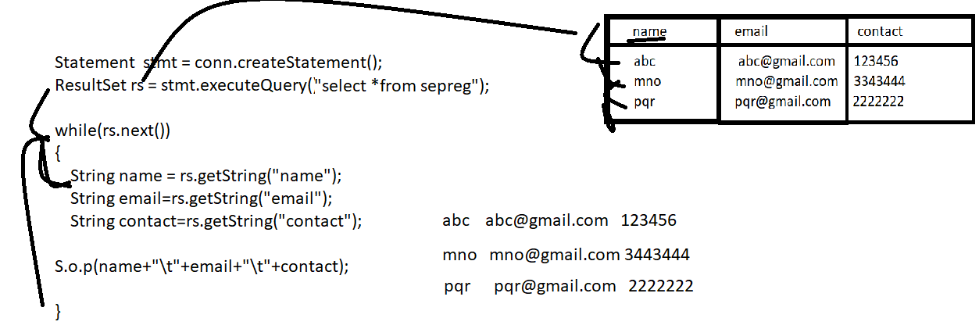

if we think about above code we have while(rs.next()) statement this statement execute whenever record present in database table and rs.getString(“name”) fetch data from name column , rs.getString(“email”) fetch data from email column and rs.getString(“contact”) fetch data from contact table.

package org.techhub;
import java.sql.*;
public class SelectQueryApplication {
public static void main(String[] args)throws SQLException {

com.mysql.cj.jdbc.Driver d = new com.mysql.cj.jdbc.Driver();
DriverManager.registerDriver(d);
Connection conn=DriverManager.getConnection("jdbc:mysql://localhost:3306/mysql","root","root");
if(conn!=null) {
Statement stmt=conn.createStatement();
ResultSet rs=stmt.executeQuery("select *from sepreg");
while(rs.next()) {
String name=rs.getString("name");
String email=rs.getString("email");
String contact=rs.getString("contact");
System.out.println(name+"\t"+email+"\t"+contact);
}
}
else {
System.out.println("Not connected");
}
}
}

Even you can fetch data from database table by using index.
When we write select query then every column has internally index
Suppose consider we have table name as sepreg with column name email and contact and if we write query
select *from sepreg
So here name has 1 index, email has 2nd index and contact has 3rd index
Suppose consider we have table name as sepreg with column name ,email and contact and if we write query like as

select email,contact from sepreg
here email has 1 index and contact has 2nd index even email is 2nd column and contact is 3rd column
when we have partial select query in JDBC then column sequence does not matter index allocation happen from left to right as per column written in select query

ResultSet interface provide facility to us can fetch data using index of column

String getString(int index): fetch string type of data from database table using its index
int getInt(int index): fetch string type of data form database table using its index
float getFloat(int index): fetch float type of data from database table using its index
long getLong(int index): fetch long type of data from database table using its index
etc

package org.techhub;
import java.sql.*;
public class SelectQueryApplication {
public static void main(String[] args)throws SQLException {

com.mysql.cj.jdbc.Driver d = new com.mysql.cj.jdbc.Driver();
DriverManager.registerDriver(d);
Connection conn=DriverManager.getConnection("jdbc:mysql://localhost:3306/mysql","root","root");
if(conn!=null) {
Statement stmt=conn.createStatement();
ResultSet rs=stmt.executeQuery("select *from sepreg");
while(rs.next()) {
String name=rs.getString(1);
String email=rs.getString(2);
String contact=rs.getString(3);
System.out.println(name+"\t"+email+"\t"+contact);
}
}
else {
System.out.println("Not connected");
}
}
}

Assignment :
Create table name as employee with field id,name,email,contact ,sal and perform following operation on it.
Case 1: Insert record of employee
Case 2: select all records of employee
Case 3: delete employee record by using its id.
Case 4: update employee record by using its id
Case 5: fetch employee record by using its name and id
Case 6: fetch employee record who is taking second highest salary
Case 7: fetch employee record whose name ends with sh and start with r

PreparedStatement interface : PreparedStatement interface is used for perform all DML operation on database same like as Statement interface.

Q. Why use PreparedStatement interface if we have Statement already?
1) When we use Statement interface and if we want to pass run time parameter to SQL Statement we need to handle SQL Injection and SQL Injection handling is very tedious task at real time when we have large number of parameter.
SQL Injection is not secure way to pass parameter to database query But if we use PreparedStatement interface we not need to handle SQL Injection. PreparedStatement interface provide facility to us to pass run time parameter to SQL Statement without using SQL Injection
2) if we have SQL Query and if we want to execute same query multiple time then Statement can execute complete query multiple time but PreparedStatement interface execute query only once and update only parameter
3) Statement interface can use for alter create, Drop Statement but PreparedStatement can use for execute query which to be executed multiple times.
4) Statement is low performance as compare PreparedStatement.
5) Statement is parent of PreparedStatement
6) Statement interface can use for execute normal query not read binary data but PreparedStatement can use for read binary data.
etc

How To works with PreparedStatement interface
__________________________________________________________________________________
If we want to work with PreparedStatement interface we have following steps.
I) Add java.sql package in application:
import java.sql.*;
II) Create Reference of PreparedStatement interface
__________________________________________________
for creating reference of PreparedStatement interface we have prepareStatement() method of Connection and this method return reference of PreparedStatement interface.
Syntax:
PreparedStatement ref =connref.prepareStatement(String sqlStatement);

Sample code
package org.techhub;
import java.sql.*;
import com.mysql.jdbc.Driver;
public class PstmtApplication {
public static void main(String[] args)throws SQLException
{ com.mysql.cj.jdbc.Driver d = new com.mysql.cj.jdbc.Driver();
DriverManager.registerDriver(d);
Connection conn=DriverManager.getConnection("jdbc:mysql://localhost:3306/mysql","root","root");
if(conn!=null) {
PreparedStatement stmt=conn.prepareStatement("insert into sepreg values(?,?,?)");
}
else {
System.out.println("Not Connected");
}
}
}
If we think about above code we found? in SQL statement within prepareStatement. This ? mark indicate we want to pass parameter to SQL Query using PreparedStatement interface and PreparedStatement interface provide some setter method to us for passing parameter to SQL statement
Methods of PreparedStatement
1) void setString(int index,String data): this method is used for pass string type of data to sql statement using its index and index start from 1 and first ? (Question mark) is first index from left to right.
2) void setInt(int index,int data): this method is used for pass integer type of data to sql statement using its index
3) void setFloat(int index,float data): this method can set float type of data to sql statement
4) void setLong(int index,long data): set long type of data to sql statement.
5) void setShort(int index,short data): set the short type of data to sql statement.
6) void setCharacterStream(int index,Reader,int size):this method is used for pass text file as parameter or character as parameter to sql
7) void setBinaryStream(int index,InputStream,int size): this method is used for pass binary data to sql statement.
Following diagram demonstrate how to pass parameter to SQL Statement.

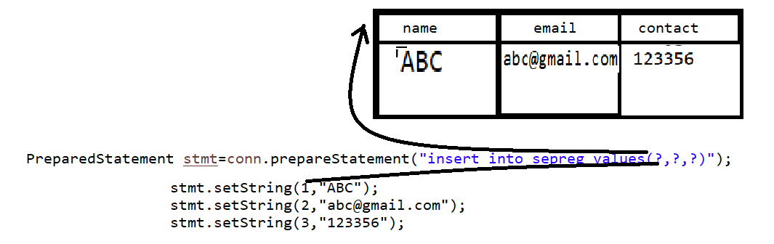

if we think about above diagram we have three parameter in SQL statement first ? parameter index is 1 and points to name column,second ? parameter index is 2 and points to email and third ? mark points to 3rd index and points to contact.
III) use its executeUpdate() and executeQuery() method:
int executeUpdate(): this method is used for perform all dml statement except select and if statement executed successfully return 1 otherwise return 0
ResultSet executeQuery(): this method is used for execute select query and return all data in ResultSet reference.

Example: we want to name,email and contact from keyboard and store in database table.
package org.techhub;
import java.sql.*;
import java.util.*;
import com.mysql.jdbc.Driver;
public class PstmtApplication {
public static void main(String[] args) throws SQLException {
com.mysql.cj.jdbc.Driver d = new com.mysql.cj.jdbc.Driver();
DriverManager.registerDriver(d);
Connection conn = DriverManager.getConnection("jdbc:mysql://localhost:3306/mysql", "root", "root");
if (conn != null) {
Scanner xyz = new Scanner(System.in);
System.out.println("Enter name email and contact");
String name = xyz.nextLine();
String email = xyz.nextLine();
String contact = xyz.nextLine();
PreparedStatement stmt = conn.prepareStatement("insert into sepreg values(?,?,?)");
stmt.setString(1, name);
stmt.setString(2, email);
stmt.setString(3, contact);
int value = stmt.executeUpdate();
if (value > 0) {
System.out.println("Record Save Successfully.................");
} else {
System.out.println("Record Not Save Success...............");
}
} else {
System.out.println("Not Connected");
}
}
}

Example: WAP to input email address and delete record from database table using email
package org.techhub;
import java.sql.*;
import java.util.*;
public class DeleteRecordApplication {
public static void main(String[] args)throws Exception {
com.mysql.cj.jdbc.Driver d = new com.mysql.cj.jdbc.Driver();
DriverManager.registerDriver(d);
Connection conn=DriverManager.getConnection("jdbc:mysql://localhost:3306/mysql","root","root");
if(conn!=null) {
Scanner xyz = new Scanner(System.in);
System.out.println("Enter email address");
String email=xyz.nextLine();
PreparedStatement stmt=conn.prepareStatement("delete from sepreg where email=?");
stmt.setString(1, email);
int value=stmt.executeUpdate();
if(value>0) {
System.out.println("Record Deleted Success..............");
}
else {
System.out.println("Some problem is there.................");
}

}
else {
System.out.println("Not Connected");
}
}
}

Example: WAP to Input name email and contact from keyboard and update name and contact using email
package org.techhub;
import java.sql.*;
import java.util.*;
import com.mysql.jdbc.Driver;
public class UpdateRecordApp {
public static void main(String[] args) throws SQLException {
com.mysql.cj.jdbc.Driver d = new com.mysql.cj.jdbc.Driver();
DriverManager.registerDriver(d);
Connection conn = DriverManager.getConnection("jdbc:mysql://localhost:3306/mysql", "root", "root");
if (conn != null) {
Scanner xyz = new Scanner(System.in);
System.out.println("Enter name contact and email");
String name = xyz.nextLine();
String contact = xyz.nextLine();
String email = xyz.nextLine();
PreparedStatement stmt;
stmt = conn.prepareStatement("update sepreg set name=? ,contact =? where email=?");
stmt.setString(1, name);
stmt.setString(2, contact);
stmt.setString(3, email);
int value = stmt.executeUpdate();
if (value > 0) {
System.out.println("Record updated success..................");
} else {
System.out.println("Some problem is there........................");
}
} else {
System.out.println("Not Connected");
}
}
}
Example: WAP to fetch all records from sepreg table.
package org.techhub;
import java.sql.*;
public class SelectRecordApp {
public static void main(String[] args)throws SQLException {
com.mysql.cj.jdbc.Driver d = new com.mysql.cj.jdbc.Driver();
DriverManager.registerDriver(d);
Connection conn=DriverManager.getConnection("jdbc:mysql://localhost:3306/mysql","root","root");
if(conn!=null) {
PreparedStatement stmt=conn.prepareStatement("select *from sepreg");
ResultSet rs=stmt.executeQuery();
while(rs.next()) { System.out.println(rs.getString("name")+"\t"+rs.getString("email")+"\t"+rs.getString("contact"));
}
}
else {
System.out.println("Database is not connected");
}
}
}

How to use where clause in PreparedStatement interface.
______________________________________________________________________________
If we use where clause in PreparedStatement interface and if we give ? As parameter after where then that values should be provided by PrepraedStatement interface and before from columns values fetch using ResultSet interface

Example: WAP to fetch name from sepreg table using its email address.
package org.techhub;
import java.sql.*;
import java.util.*;
public class SelectRecordApp {
public static void main(String[] args)throws SQLException {
com.mysql.cj.jdbc.Driver d = new com.mysql.cj.jdbc.Driver();
DriverManager.registerDriver(d);
Connection conn=DriverManager.getConnection("jdbc:mysql://localhost:3306/mysql","root","root");
if(conn!=null) {
Scanner xyz = new Scanner(System.in);
System.out.println("Enter email");
String email=xyz.nextLine();
PreparedStatement stmt=conn.prepareStatement("select name from sepreg where email=?");
stmt.setString(1, email);
ResultSet rs=stmt.executeQuery();
if(rs.next()) {
System.out.println(rs.getString("name"));
}
else {
System.out.println("Record not found");
}
}
else {
System.out.println("Database is not connected");
}
}
}

Example using joins
package org.techhub;
import java.sql.*;
import java.util.*;
public class SelectRecordApp {
public static void main(String[] args)throws SQLException {
com.mysql.cj.jdbc.Driver d = new com.mysql.cj.jdbc.Driver();
DriverManager.registerDriver(d);
Connection conn=DriverManager.getConnection("jdbc:mysql://localhost:3306/mysql","root","root");
if(conn!=null) {
PreparedStatement stmt=conn.prepareStatement("select c.name as 'Course Name', s.name as 'Student Name',c.fees as 'Course Fees' from course c inner join coursestudentjoin cs on c.cid=cs.cid inner join student s on s.sid=cs.sid");
ResultSet rs=stmt.executeQuery();
while(rs.next()) {
System.out.println(rs.getString(1)+"\t"+rs.getString(2)+"\t"+rs.getInt(3));
}
}
else {
System.out.println("Database is not connected");
}
}
}

5) Close Connection

